CA Way Programming Experience Library
Search
Advanced Search Create New
Overview
Name Type Min Time
Brief Skill Level Facilitation Complexity
Theme (check box) Ages

Feedback (0) Main Activity Image Browse
Categories Environments Learning Outcomes (Check box)
- CA Active Play Indoor Gymnasium/Hall
Add check box list for Skills & Attributes
- CA STEM Indoor OSHC room
- CA Performing Arts Indoor Kitchen
- CA Creativity Indoor Other
- CA Imaginative Play Outdoors Oval
- CA Construction Outdoors Court
- CA Environment Outdoors Playground
- CA Leaders Outdoors Nature
- CA Healthy Lifestyles Outdoors Other
Details
Resources Add
Resource – enter as auto bullet points, allows copy/paste
Planning Considerations Add
Type | Tip
Instructions Add
No. | Instruction
Additional information and resources Add
Date Uploaded | File Name | Type |  | Submit
Approval Publish/Withdraw Note
History
Date Previous Status New Status Notes
Published Applications One Team Partner Portal Parent Portal
Helps with editing in OCW
In case the name is not known at the time of the search

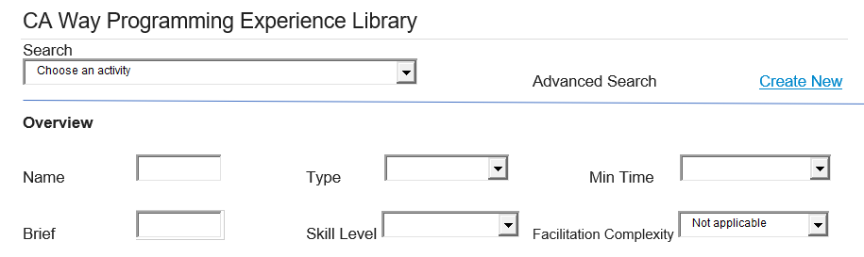

Free text or auto suggest

Hover bubble, explains

Experience/Project
200 word limit
Description of the activity
Child led, Open Ended, Support Required, Direct Supervision & Engagement

Beginner/Intermediate/ Advanced

Hover bubble, explains

Hover bubble, explains

Must select at least one, can be multiple

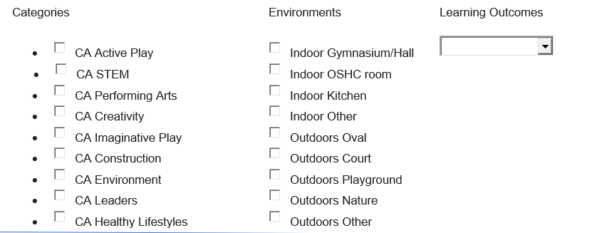
Must select at least one, can be multiple

Drop down box, can select more than one, list from CA Way Framework

Type = Drop down box: Preparation, Safety, Engagement, Adaptation, Extension
Tip = free form text
Hover bubble, reminds them to include quantities
Bullet point list of items required, allows multiple entries at once/supports copy-paste

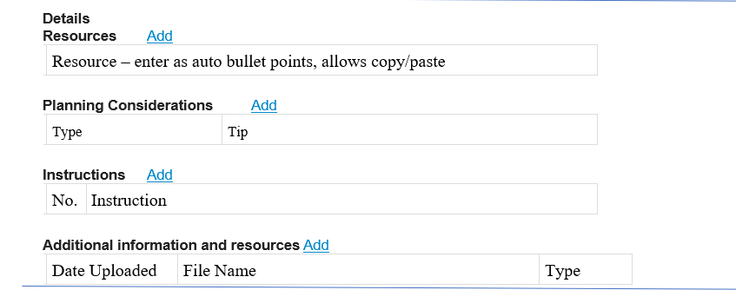

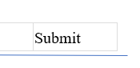

Shaded out until all compulsory areas are completed
Supports links, uploads of additional guides and resources, additional photos of steps etc. Optional
No = automatic bullet points
Instruction = free form text
Allow copy/paste for multiple entries at once
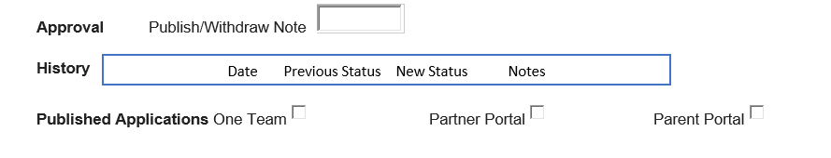
For OCW end only, approver only
Where to send it.
Need to consider specific services and parent groups – not just ‘send all’
Auto tracks changes to file
Free form text

CA Way Experience Card

Name Photo
Brief:___________________________________________________________________________________
Safety First:_____________________________________________________________________________
Environments:__________________ Duration:_______________ Skill Level:____________________
# children :_____________________ # pieces:_______________ Facilitation complexity:___________
Learning Outcome:_______________________________________________________________________
Resources

Planning considerations

Instructions

Additional Information & resources

NB: Remember to rate this experience
Close

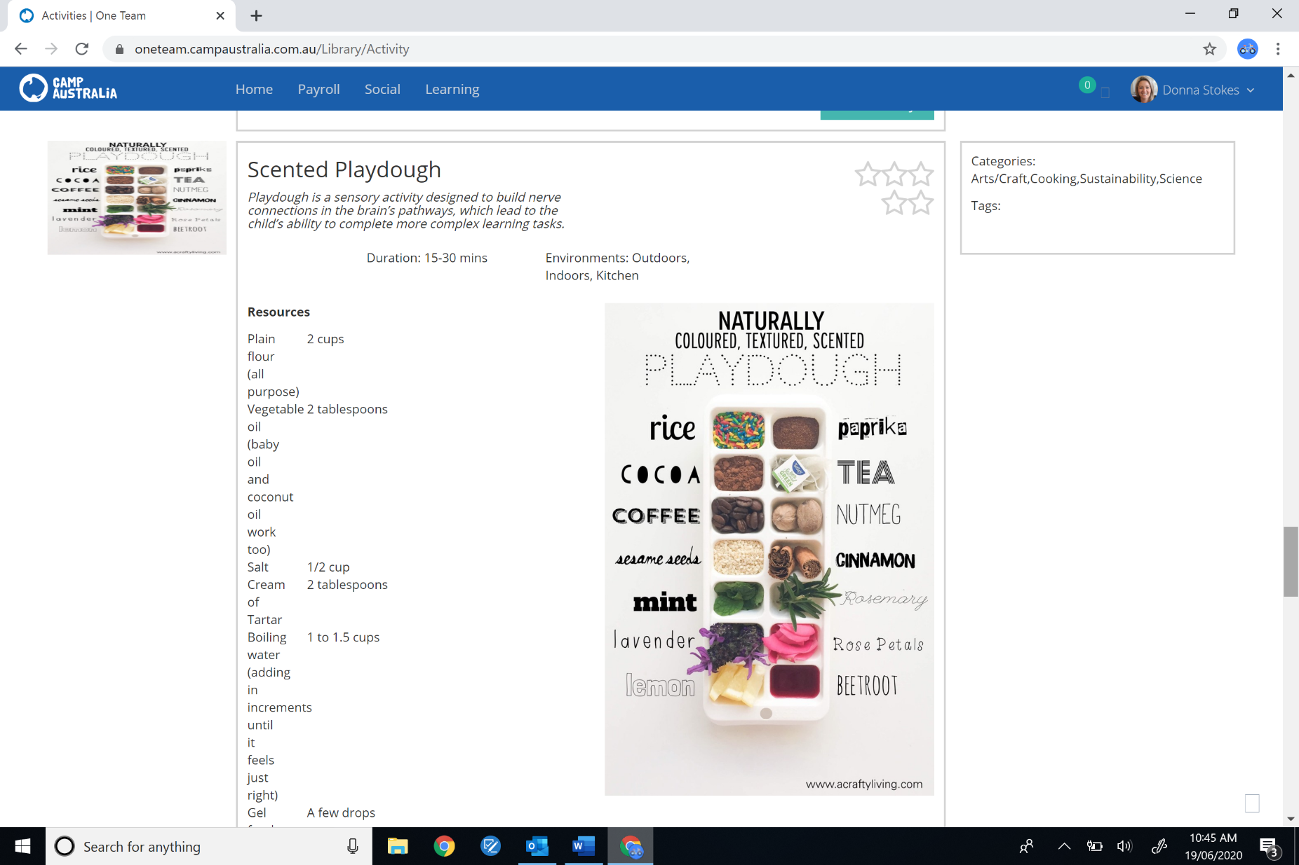
This needs to read & print like a card, all details on one page

